TC-CMS-009
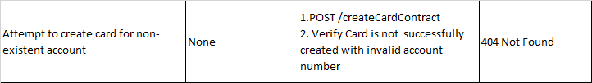
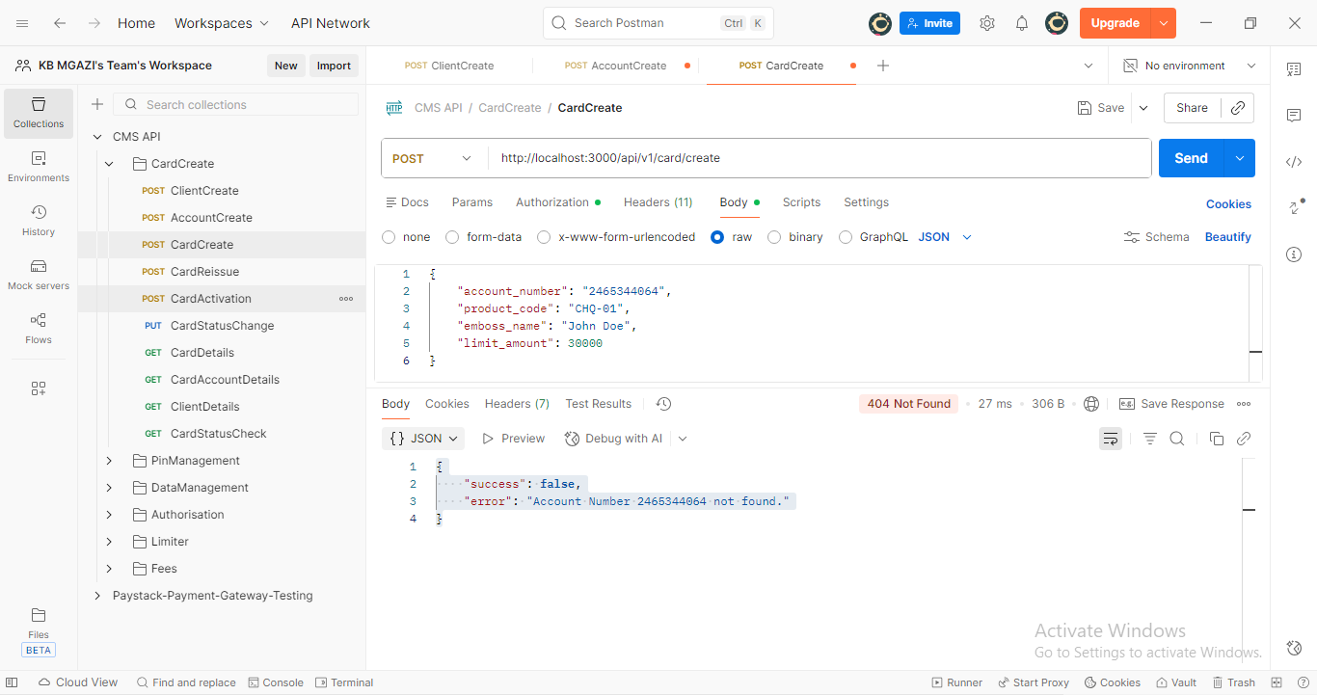
Request:
{
"account_number": "2465344064",
"product_code": "CHQ-01",
"emboss_name": "John Doe",
"limit_amount": 30000
}

Response:
{
"success": false,
"error": "Account Number 2465344064 not found."
}

